**Roll No: 1803108**

**Lab Performance Test [1]**

**Lab Task Q[1]**

**Question:** **Consider given code, #include<math.h> int main(){ float a=1; float b=2; float c=a+b; return 0; } . Show preprocess output file generated by C compiler along with Makefile (point penalty for adding extra commands other than necessary).**

**Solution (Bold your own written code):**

|  |
| --- |
| Makefile Code:  **All:**  **gcc -E proc.c > proc.i** |

**Output (Screen/SnapShot):**

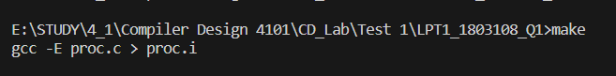

**Lab Task Q[2a]**

**Question:** **Consider given statements, 1. Batman 1 Movie 2. AntMan 2 Movie 3. SpiderWoman 4 Movie . a) Show a flex file which can tokenize given statements.**

**Solution (Bold your own written code):**

|  |
| --- |
| **%option noyywrap**  **%{**  **%}**  **%%**  **"Batman" {printf("%s -> Batman\n",yytext);}**  **"Antman" {printf("%s -> Antman\n",yytext);}**  **"SpiderWoman" {printf("%s -> SpiderWoman\n",yytext);}**  **"Movie" {printf("%s -> Movie\n",yytext);}**  **[0-9] {printf("%s -> Number\n",yytext);}**  **%%**  **int main()**  **{**  **//1803108**  **yylex();**  **return 0;**  **}** |

**Output (Screen/SnapShot):**

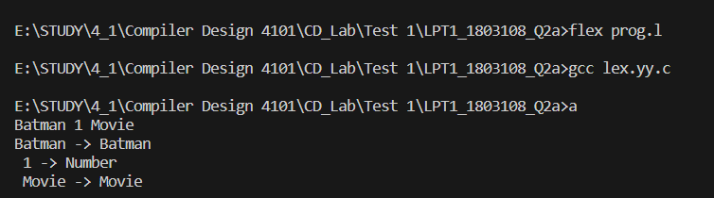

**Lab Task Q[2b]**

**Question:** **Consider given statements, 1. Batman 1 Movie 2. AntMan 2 Movie 3. SpiderWoman 4 Movie .** **b) Show a bison file which can parse given statements.**

**Solution (Bold your own written code):**

|  |
| --- |
| //Prog.l Code  **%option noyywrap**  **%{**  **#include "prog.tab.h"**  **%}**  **%%**  **"Batman" {printf("%s -> Batman\n",yytext);}**  **"Antman" {printf("%s -> Antman\n",yytext);}**  **"SpiderWoman" {printf("%s -> SpiderWoman\n",yytext);}**  **"Movie" {printf("%s -> Movie\n",yytext);}**  **[0-9] {printf("%s -> Number\n",yytext);}**  **%%**  //prog.y Code  **%{**  **#include<stdio.h>**  **int yylex();**  **void yyerror(char *s);**  **%}**  **%token Batman Antman SpiderWoman Number Movie**  **%start S**  **%%**  **S: Batman Antman SpiderWoman Number Movie**  **%%**  **int main()**  **{**  **//1803108**  **yyparse();**  **printf("Parsing Finished\n");**  **return 0;**  **}**  **void yyerror(char *s)**  **{**  **fprintf(stderr, "error: %s\n",s);**  **}** |

**Output (Screen/SnapShot):**

